Reporting No:1 Week No:1 From :15/05/2024 To :17/05/2024 College ID: 22IT116

Project Title: **E-commerce website**

**WEEKLY REPORT**

**Work done in last week ( Attach supporting Documents):**

15/05/2024 Wednesday

|  |  |
| --- | --- |
| 9:30 – 11:30 | Introduction to the MEAN stack, its components, and setup |
| 12:00– 2:30 | Installing and setting up MongoDB, and understanding its basics |
| 3:00– 5:00 | Creating a simple MongoDB database and performing CRUD operations |

16/05/2024 Thursday

|  |  |
| --- | --- |
| 9:30 – 11:30 | Introduction to Node.js and its environment |
| 12:00– 2:30 | Learning the basics of Express.js and setting up a server |
| 3:00– 5:00 | Building a RESTful API with Express.js and MongoDB |

17/05/2024 Friday

|  |  |
| --- | --- |
| 9:30 – 11:30 | Advanced Node.js concepts: asynchronous programming, event loop |
| 12:00– 2:30 | Middleware in Express.js for error handling and logging |
| 3:00– 5:00 | Implementing user authentication with JWT in the MEAN stackExpress.js and MongoDB |

**Reason for incomplete work:**

1.

**Plans for next week:**

1. To learn Mongoose and MongoDB integration and MongoDB schema and Models
2. Advanced MongoDB concepts: indexing, aggregation, and performance optimization

**References:**

1. YouTube Channel : [Thapa Technical](https://www.youtube.com/@ThapaTechnical)

**Signature of External Guide Signature of Internal Guide**

Student Id: 22IT116

Student Name: TRUSHANGKUMAR SUMANBHAI PATEL

Reporting No:2 Week No:2 From :20/05/2024 To :24/05/2024 College ID: 22IT116

Project Title: **E-commerce website**

**WEEKLY REPORT**

**Work done in last week ( Attach supporting Documents):**

1. 20/05/2024 Monday

* 9.30am to 11.30 am: Introduction to JSX and Actual browser running using babel

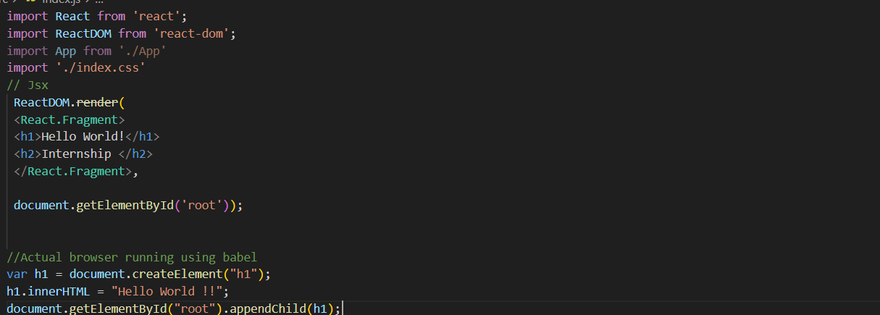

* 12.00pm to 2.30 pm: Mini project for creating List of 5 Movie and display in web

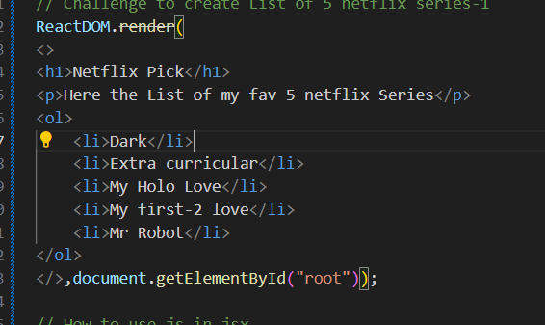

* 3.00 pm to 5.00 pm: How to use JS in JSX and Template Literals

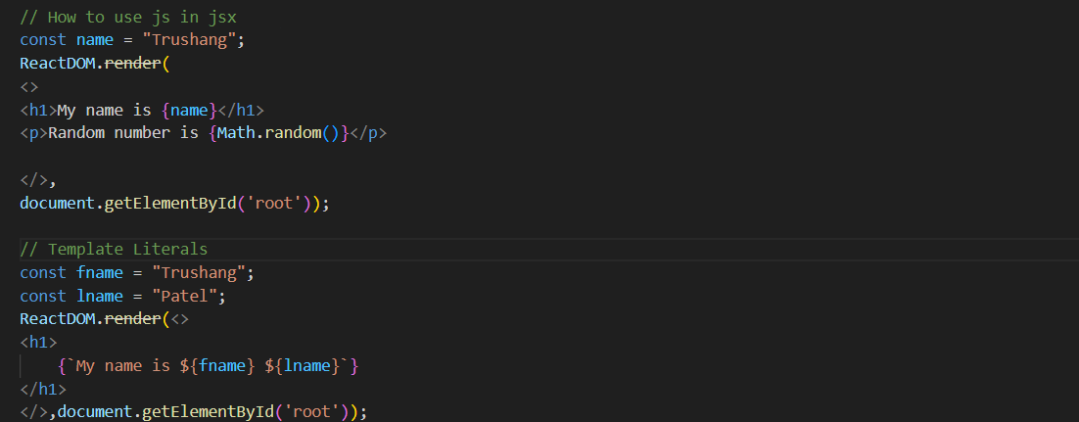

1. 21/05/2024 Tuesday

* 9.30am to 11.30 am: Creating a web page that show name

Today’s date and current time using JSX element

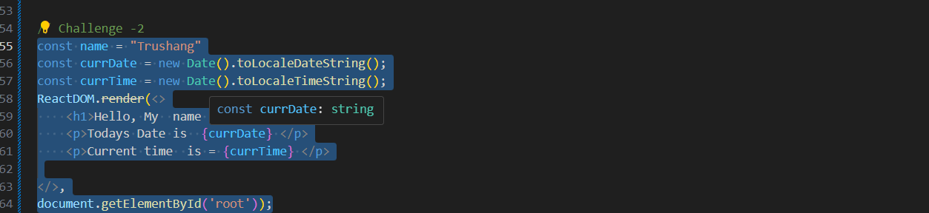

* 12.00pm to 2.30 pm: create a web site that generate 3 random image and add CSS Stying(External)

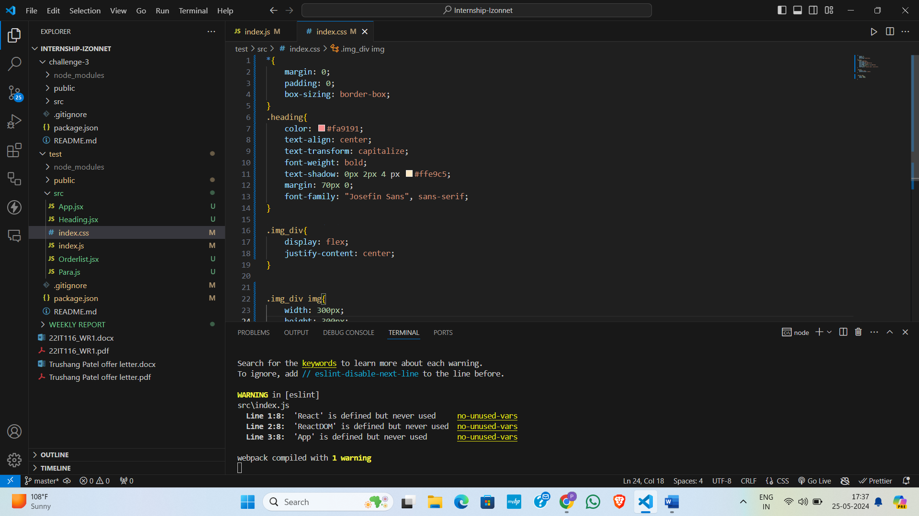

* 3.00 pm to 5.00 pm : Learn About Inline CSS styling

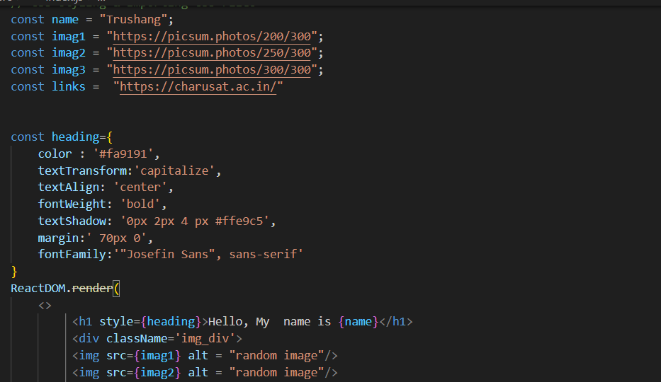

1. 22/05/2024 Wednesday

* 9.30 am to 11.30 am: Learn about components and why the use.
* 12.00pm to 2.30 pm: Implement the Components and create a simple website for greeting.

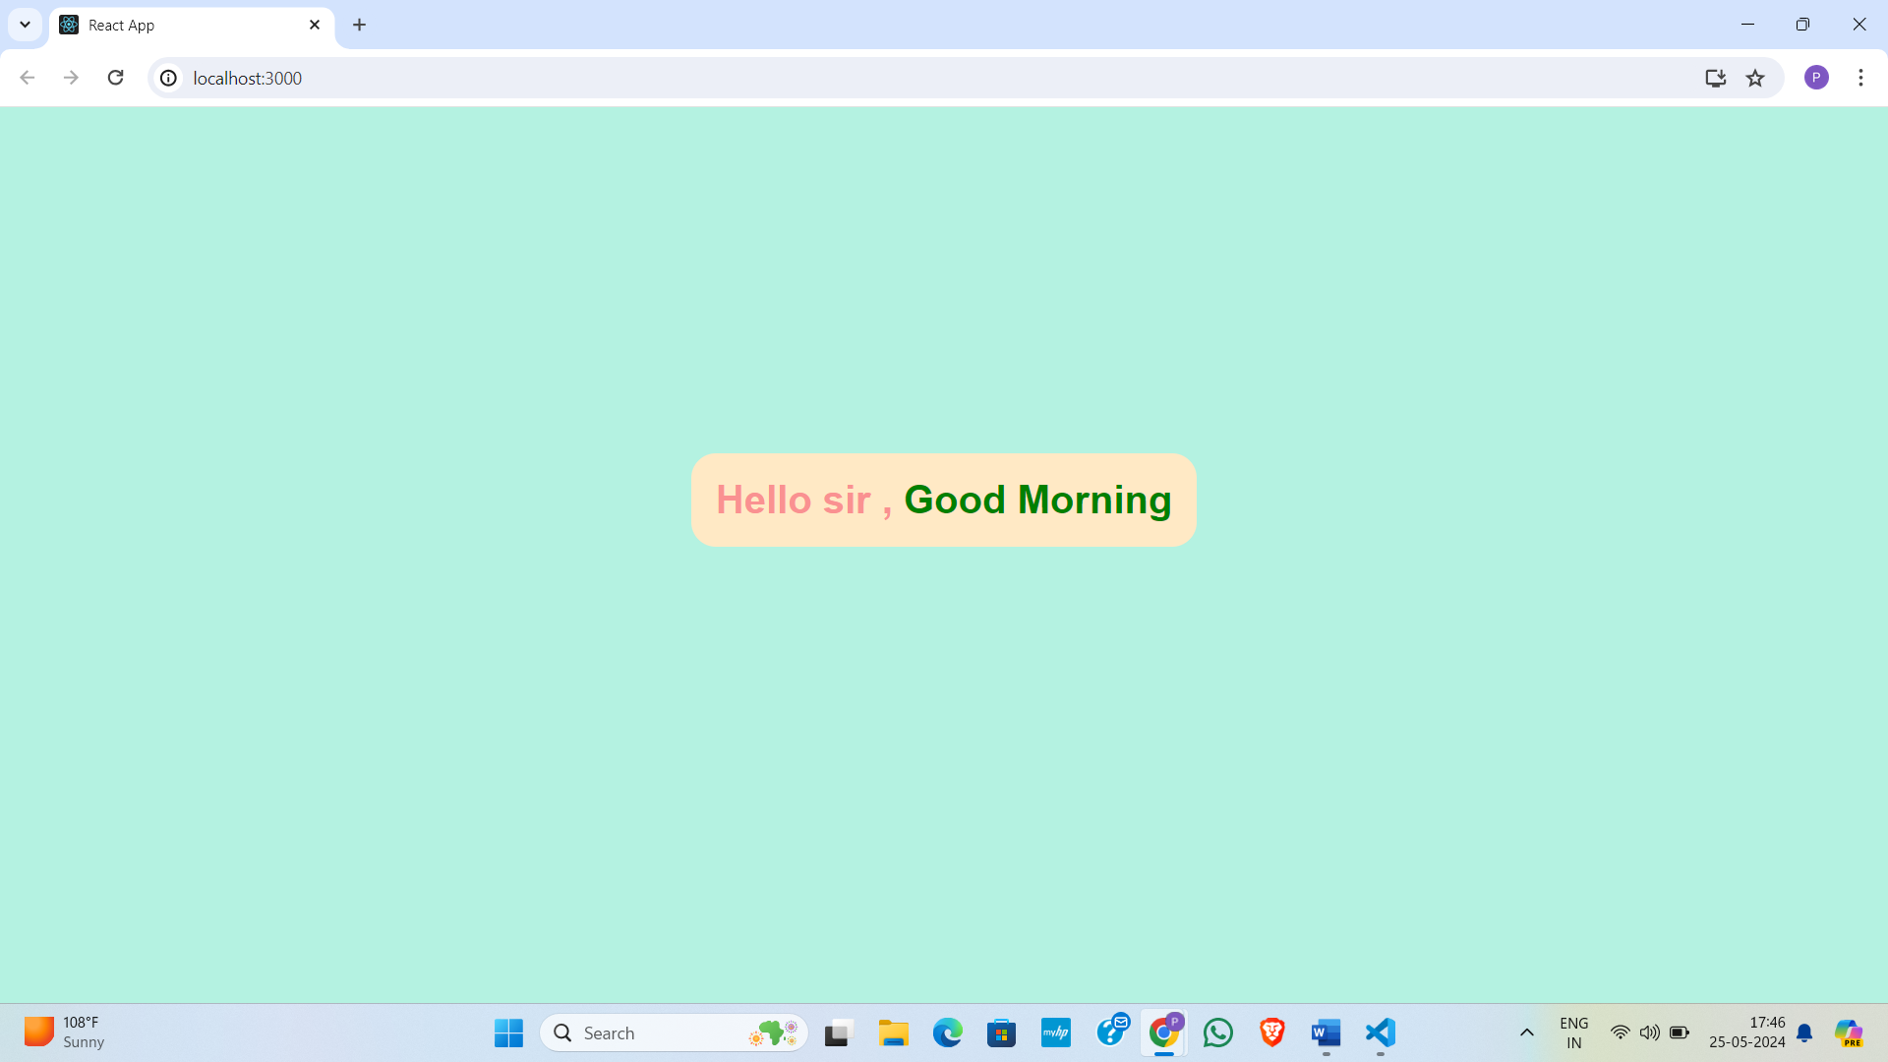

* 3.00 pm to 5.00 pm: Above created website we modify that code and create using components.

1. 23/05/2024 Thursday

* 9.30 am to 11.30 am: Learn about how to use Google fonts in our react project and props
* 12.00pm to 2.30 pm: Hooks in React js and using Hooks create a digital clock
* 3.00pm to 5.00 pm: Event Handling and Forms in React js

1. 24/05/2024 Friday

* 9.30 am to 11.30 am: How to use Material UI in our Project
* 12.00pm to 2.30 pm: How to install and use bootstrap
* 3.00pm to 5.00 pm: Learn React Router

**Plans for next week:**

1. To learn backend part for our website

**References:**

1. YouTube Channel: [Thapa Technical](https://www.youtube.com/@ThapaTechnical)
2. React Documentation

**Signature of External Guide Signature of Internal Guide**

Student Id: 22IT116

Student Name: TRUSHANGKUMAR SUMANBHAI PATEL

Reporting No:3 Week No:3 From :27/05/2024 To :31/05/2024 College ID: 22IT116

Project Title: **E-commerce website**

**WEEKLY REPORT**

**Work done in last week ( Attach supporting Documents):**

1. 27/05/2024 Monday

* 9.30am to 11.30 am: Create a top 5 Netflix series in 2024 website and use basic concepts

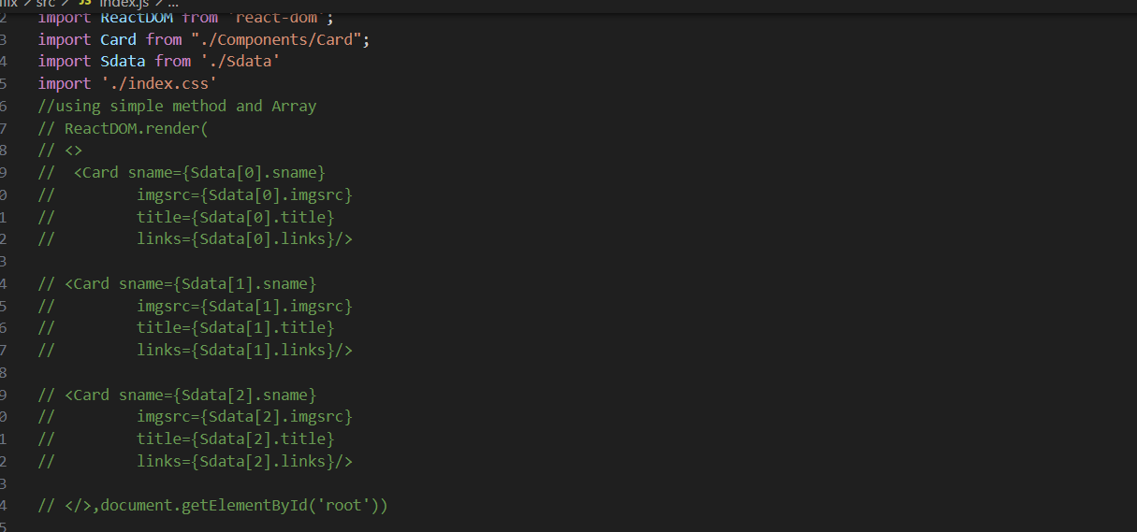

* 12.00pm to 2.30 pm: Replace simple method of Array with Mapping and add Movie and Solve error of image component

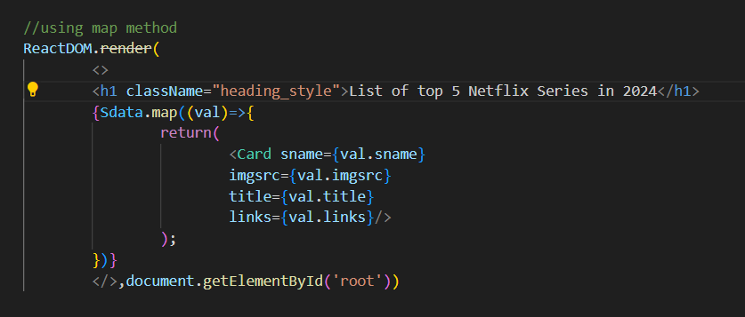

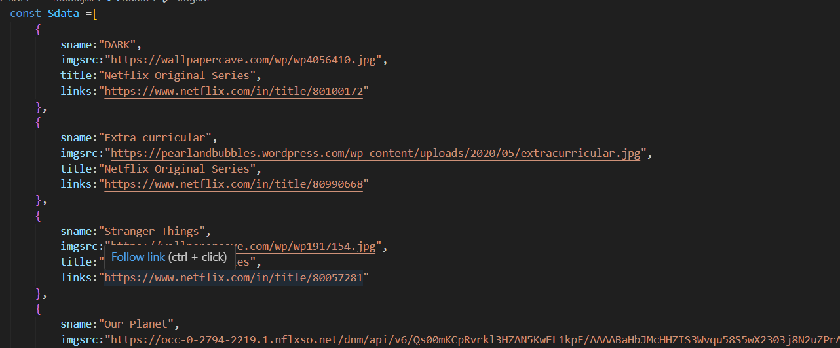

* 3.00 pm to 5.00 pm: Add CSS styling

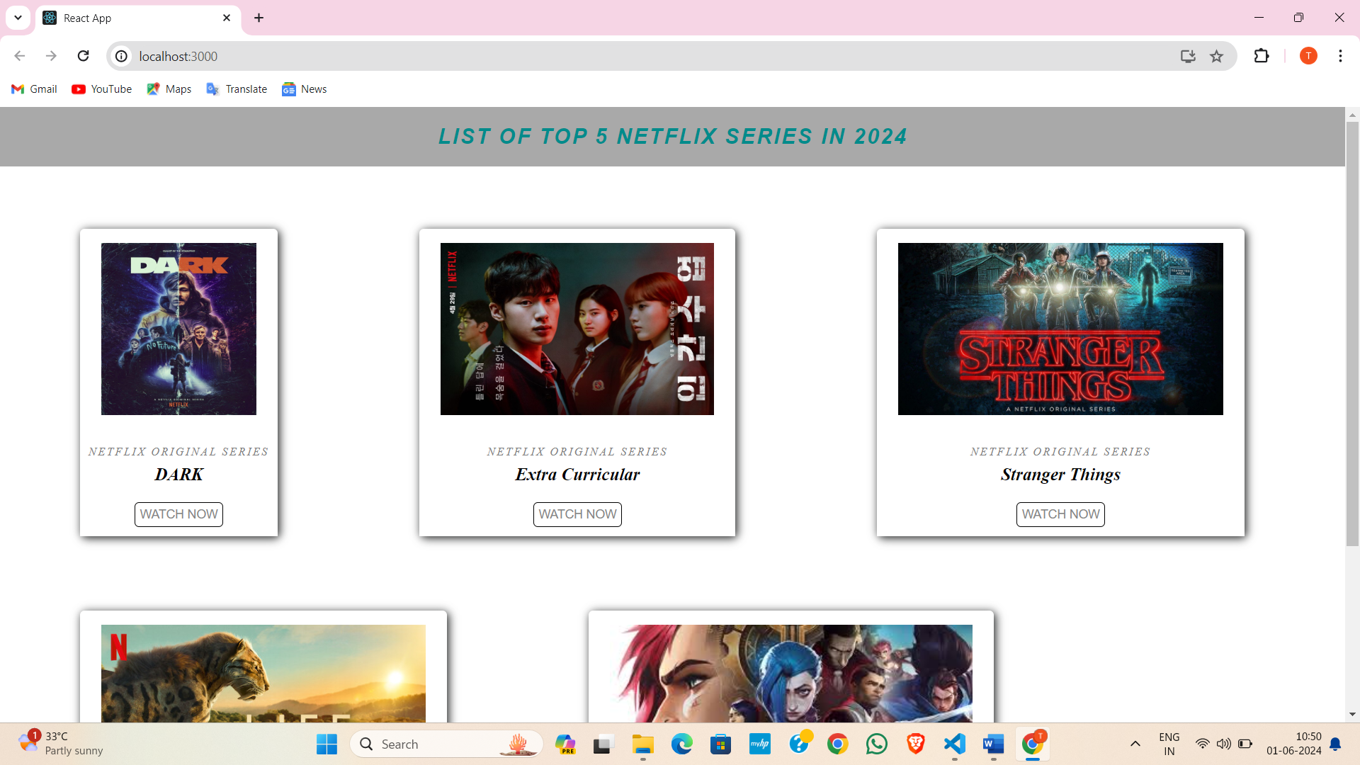

1. 28/05/2024 Tuesday

* 9.30am to 11.30 am: Create a Calculator

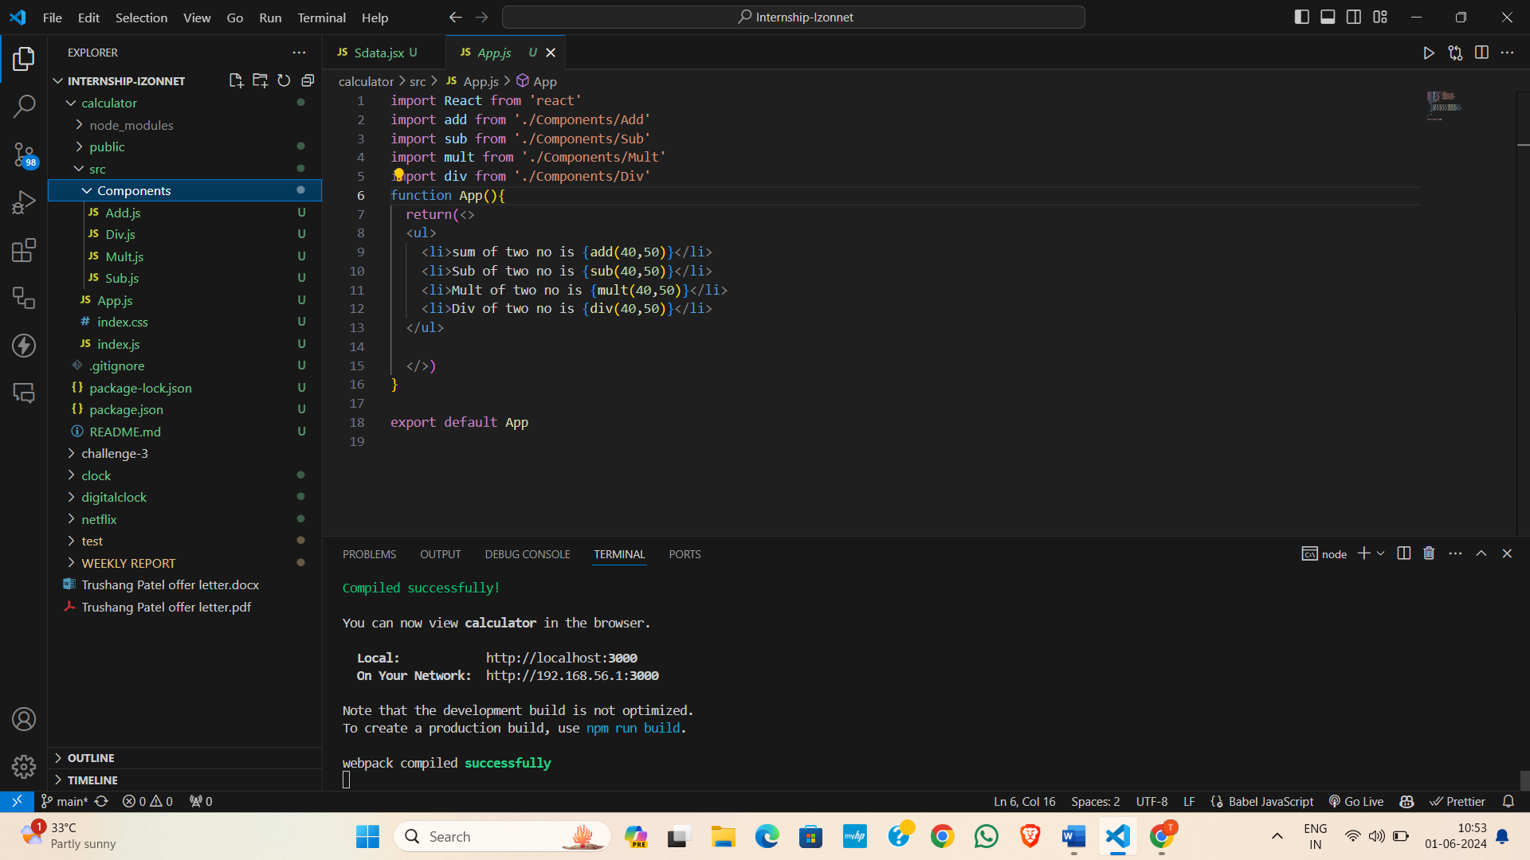

* 12.00pm to 2.30 pm: To learn about Context API

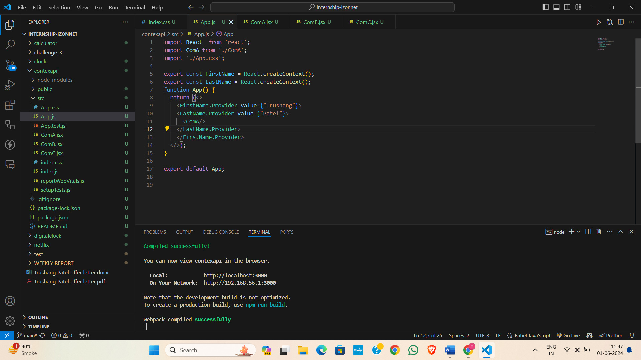

* 3.00 pm to 5.00 pm: Introduction to Express JS and how to install express js

1. 29/05/2024 Wednesday

* 9.30 am to 11.30 am: Express JS routing and how to send HTML and JSON data as a Response

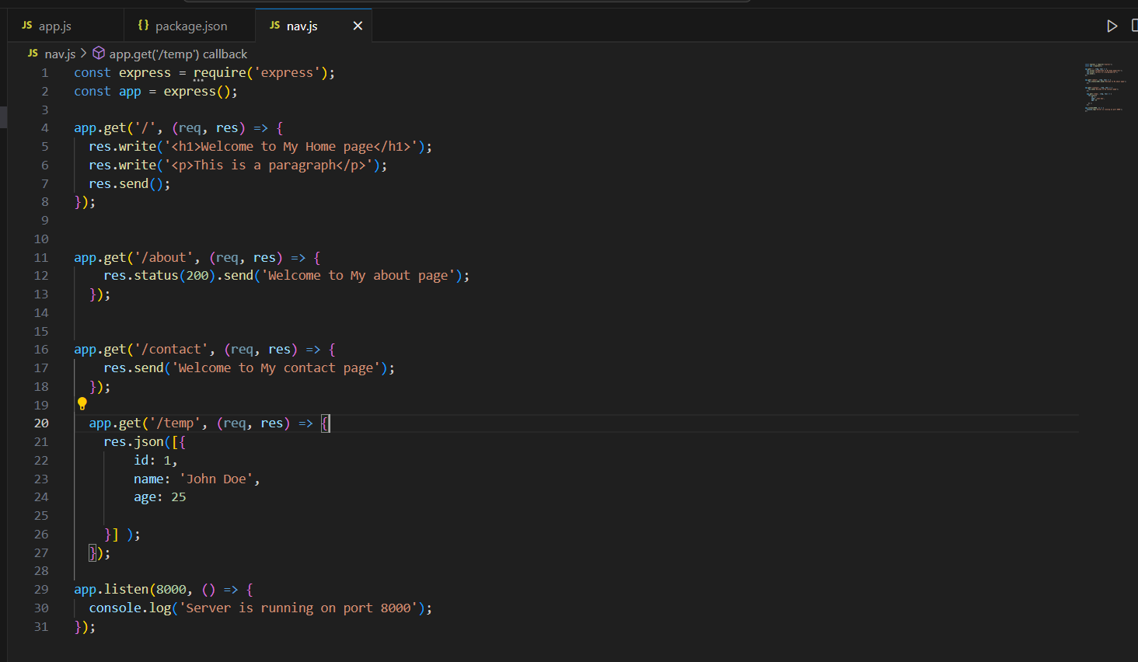

* 12.00pm to 2.30 pm: Serve HTML CSS & JS Files in Express JS | Middleware in Express JS

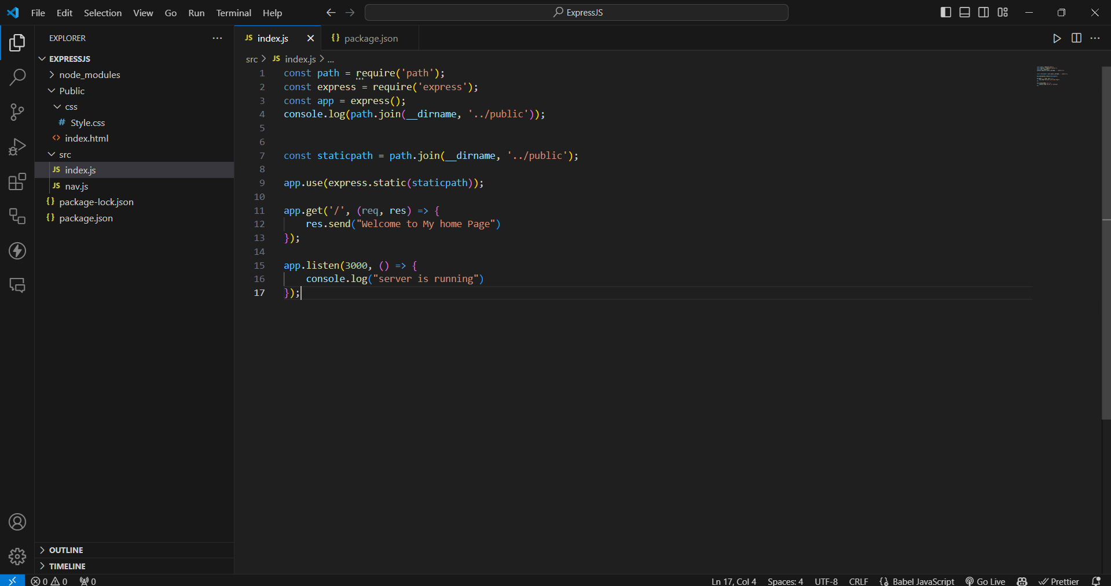

* 3.00 pm to 5.00 pm: Template Engine (Pug, hbs, EJS)

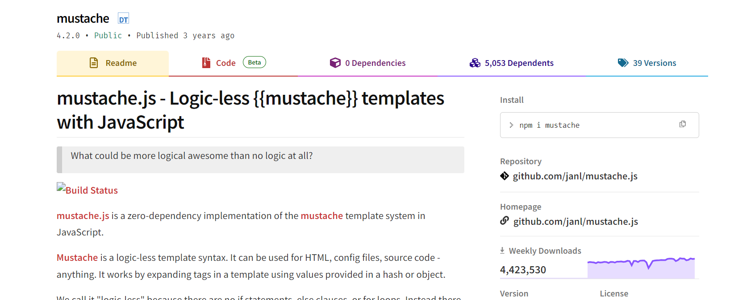

1. 30/05/2024 Thursday

* 9.30 am to 11.30 am: Customizing the Views Directory in Express JS and Using Partials

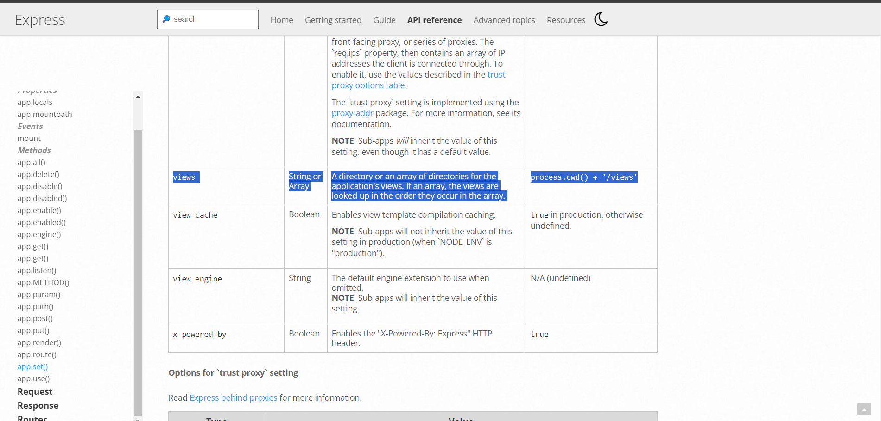

* 12.00pm to 2.30 pm: Add 404 error page in Dynamic Website using Express JS, Adding Responsive Styles to Complete Dynamic Website using CSS in Express Website
* 3.00pm to 5.00 pm: Introduction to MongoDB

1. 31/05/2024 Friday

* 9.30 am to 11.30 am: Installation of MongoDB

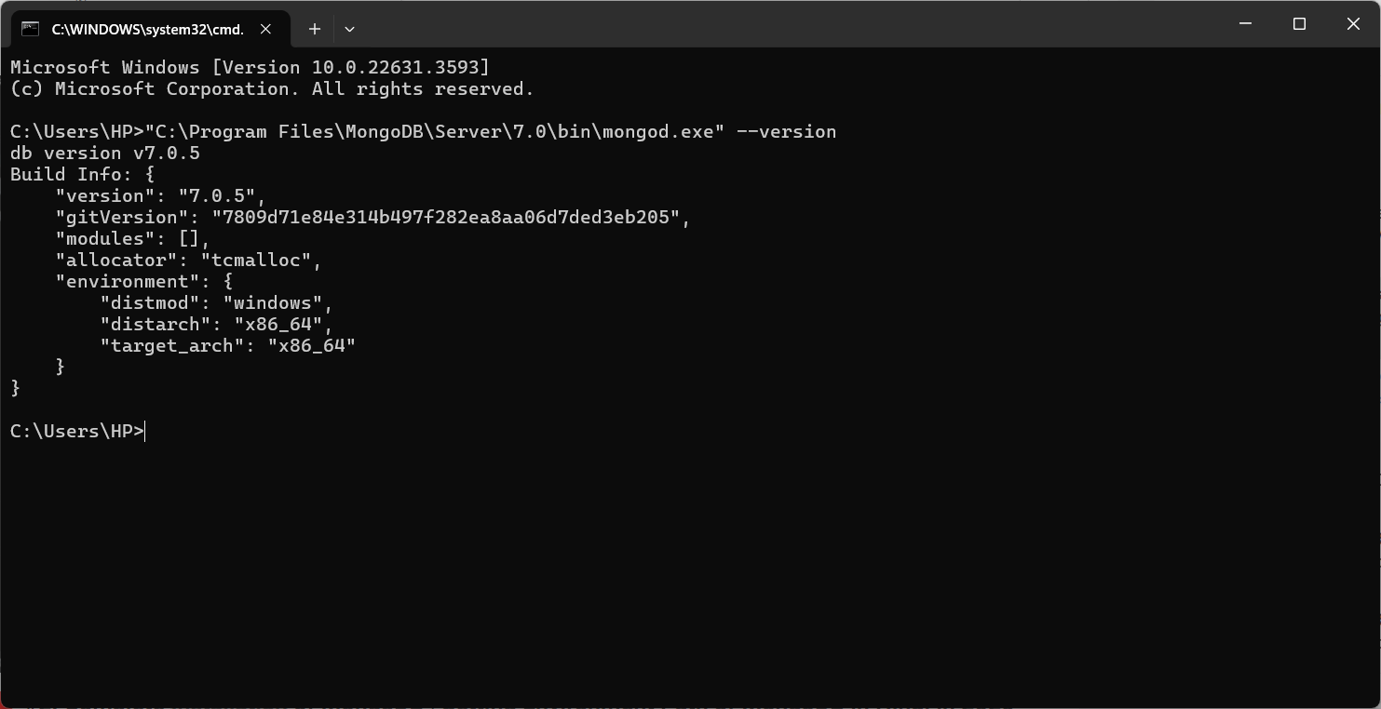

* 12.00pm to 2.30 pm: MongoDB CRUD operation and test various features
* 3.00pm to 5.00 pm: Install MongoDB GUI (MongoDB Compass) , how to connect MongoDB.

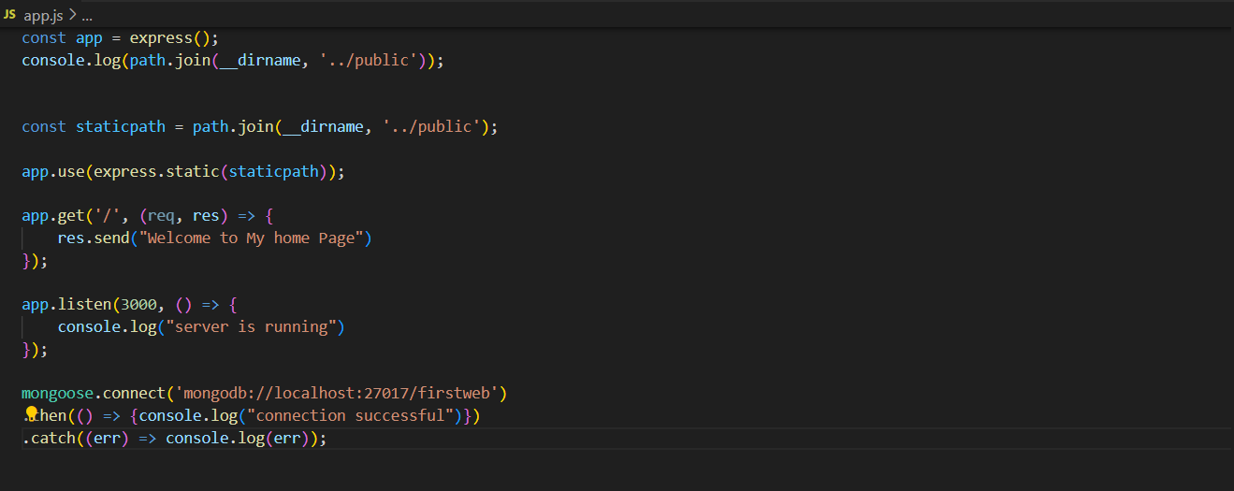

**Plans for next week:**

1. To start a Project using MERN stack

**References:**

1. YouTube Channel: [Thapa Technical](https://www.youtube.com/@ThapaTechnical)
2. React Documentation
3. Express Documentation
4. Node Documentation
5. MongoDB Documentation

**Signature of External Guide Signature of Internal Guide**

Student Id: 22IT116

Student Name: TRUSHANGKUMAR SUMANBHAI PATEL

Reporting No:4 Week No:4 From :03/06/2024 To :07/06/2024 College ID: 22IT116

Project Title: **E-commerce website**

**WEEKLY REPORT**

**Work done in last week ( Attach supporting Documents):**

1. 03/06/2024 Monday

* 9.30am to 11.30 am: Introduction about our Project.
* 12.00pm to 2.30 pm: Setup MongoDB, React, Express and node js for our project and solve MongoDB connection error

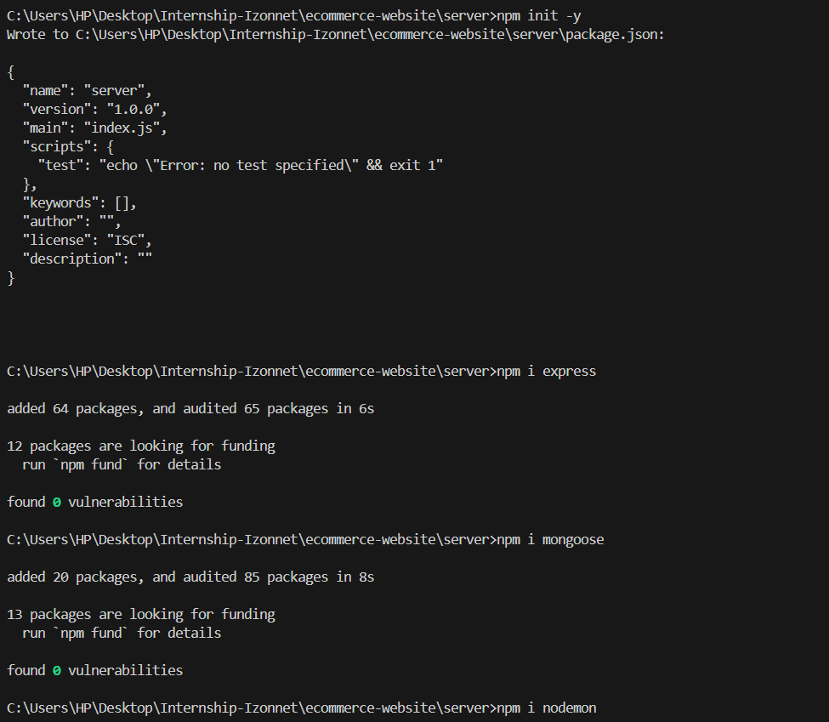

* 3.00 pm to 5.00 pm: Create Navbar add apply CSS

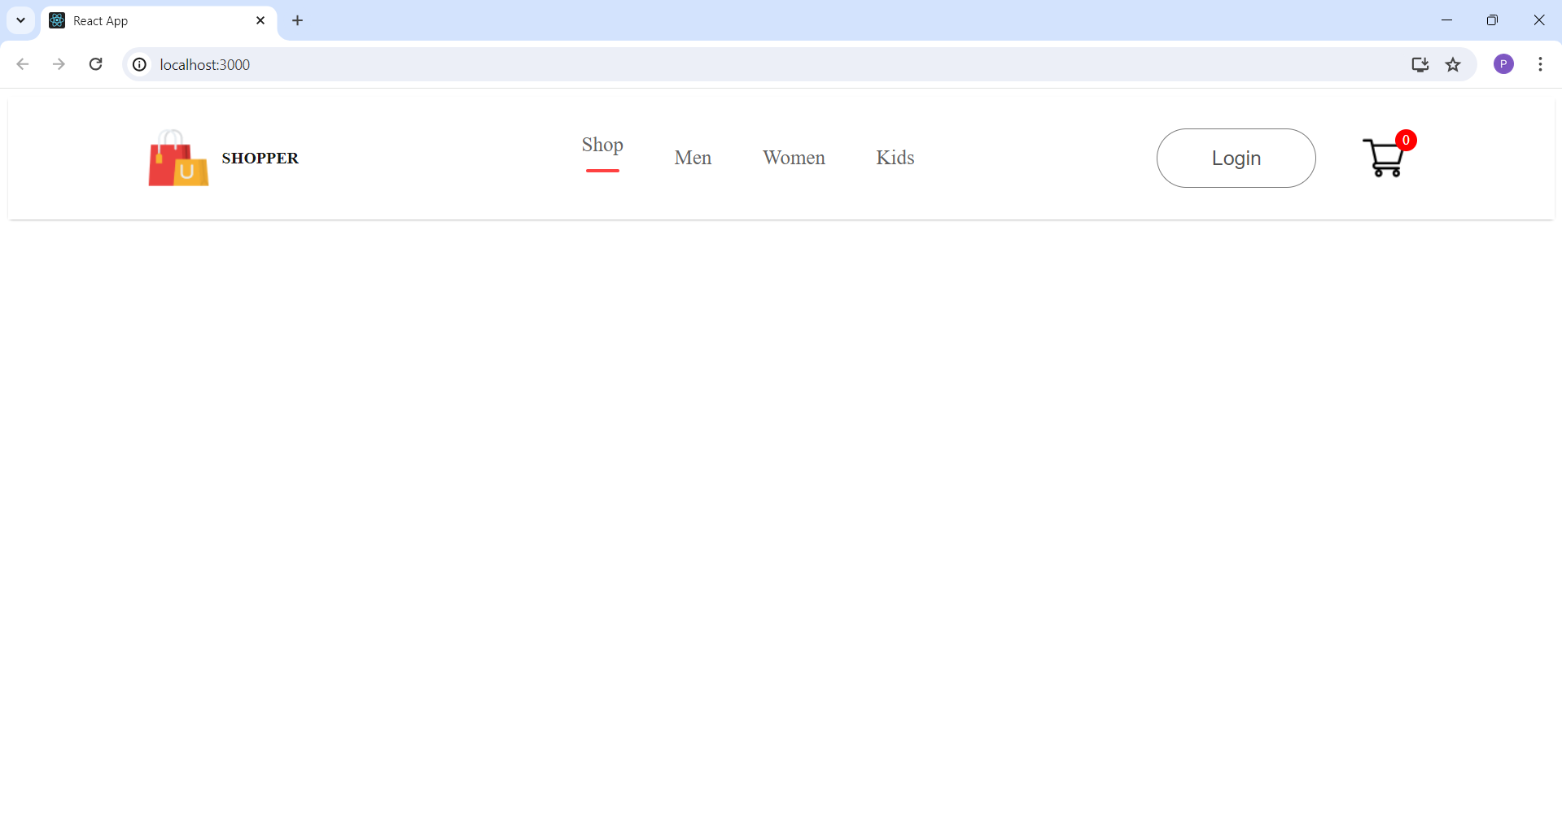

1. 04/06/2024 Tuesday

* 9.30am to 11.30 am: Solve error corresponding to CSS (CSS not apply on the class)
* 12.00pm to 2.30 pm: Create Route for Projects

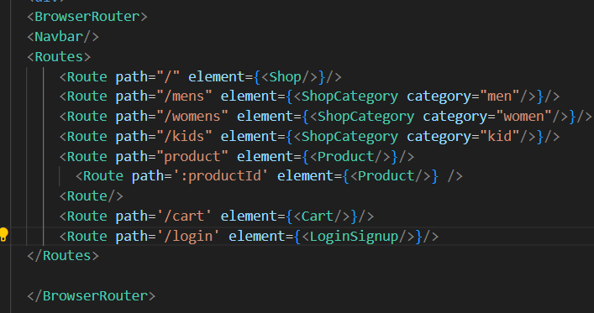

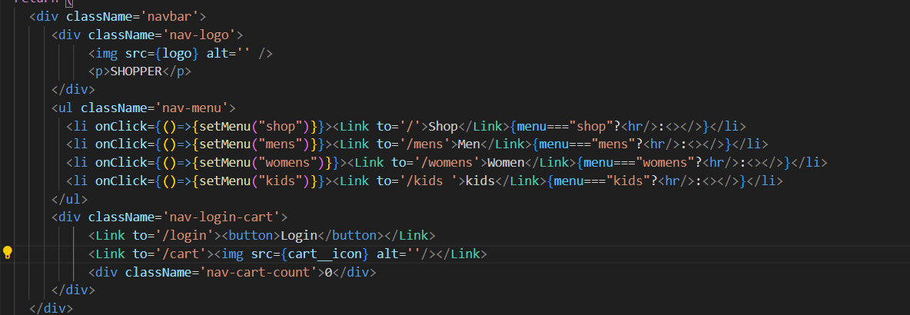

* 3.00 pm to 5.00 pm: I collect all the `picture (or photo) for my ecommerce website.

1. 05/06/2024 Wednesday

* 9.30 am to 11.30 am: Create Shop page

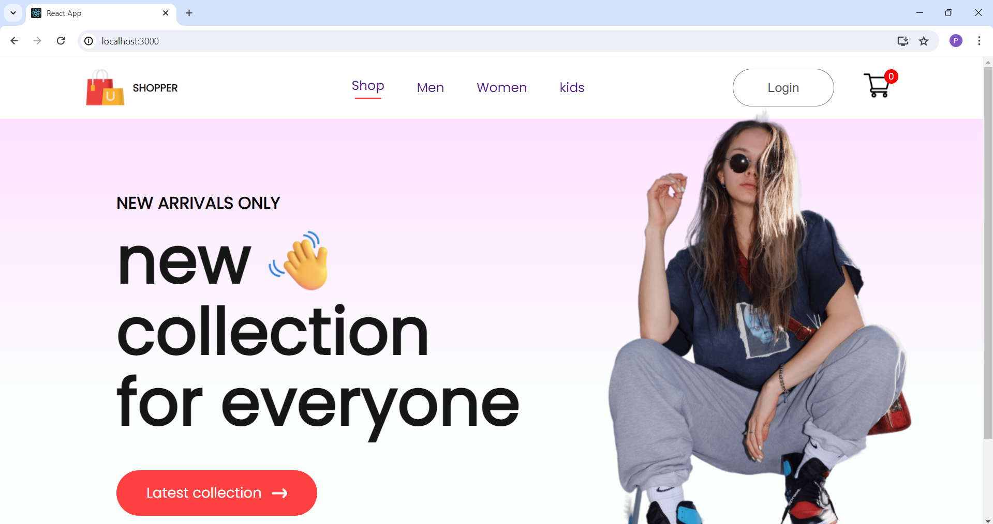

* 12.00pm to 2.30 pm: Add CSS Styling in shop page
* 3.00 pm to 5.00 pm: Creating Popular item for shop in shop page

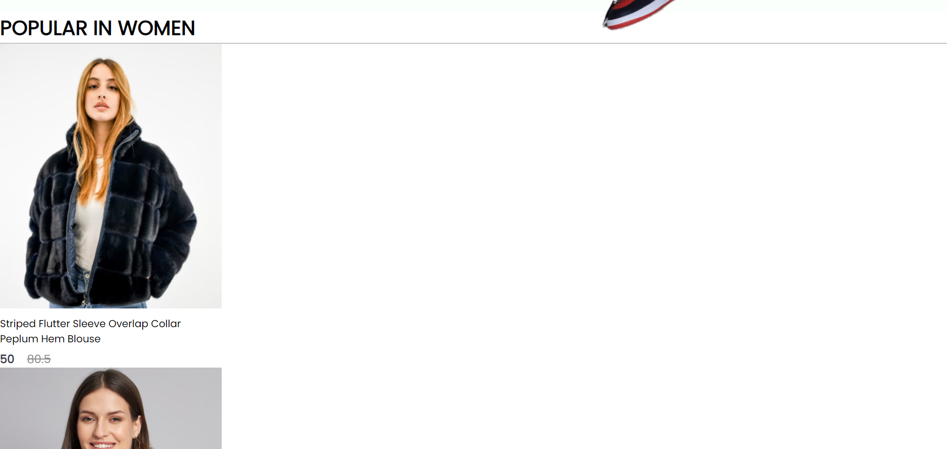

1. 06/06/2024 Thursday

* 9.30 am to 11.30 am: Add CSS styling in Popular Page

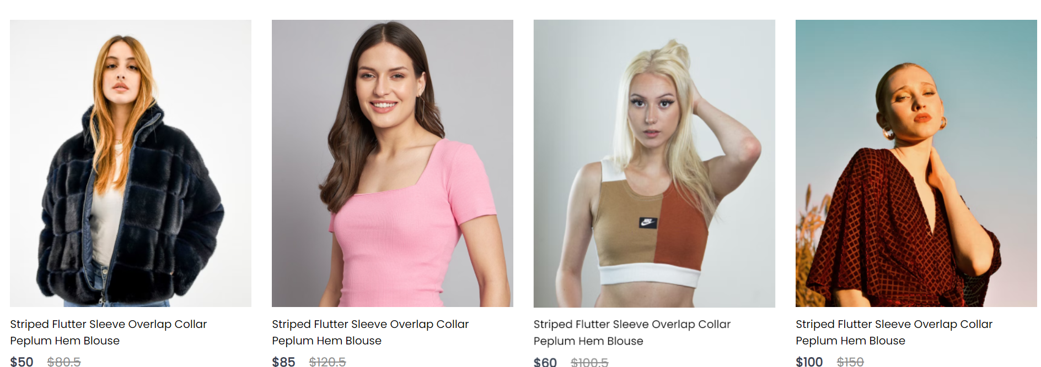

* 12.00pm to 2.30 pm: Create a Exclusive offers for customer



* 3.00pm to 5.00 pm: Add CSS for Exclusive offers for customer

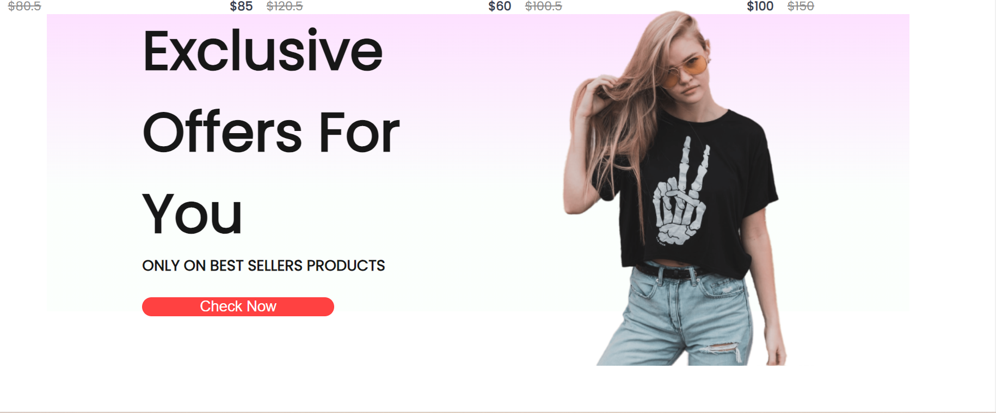

1. 07/06/2024 Friday

* 9.30 am to 11.30 am: Add new Collection Field in my project

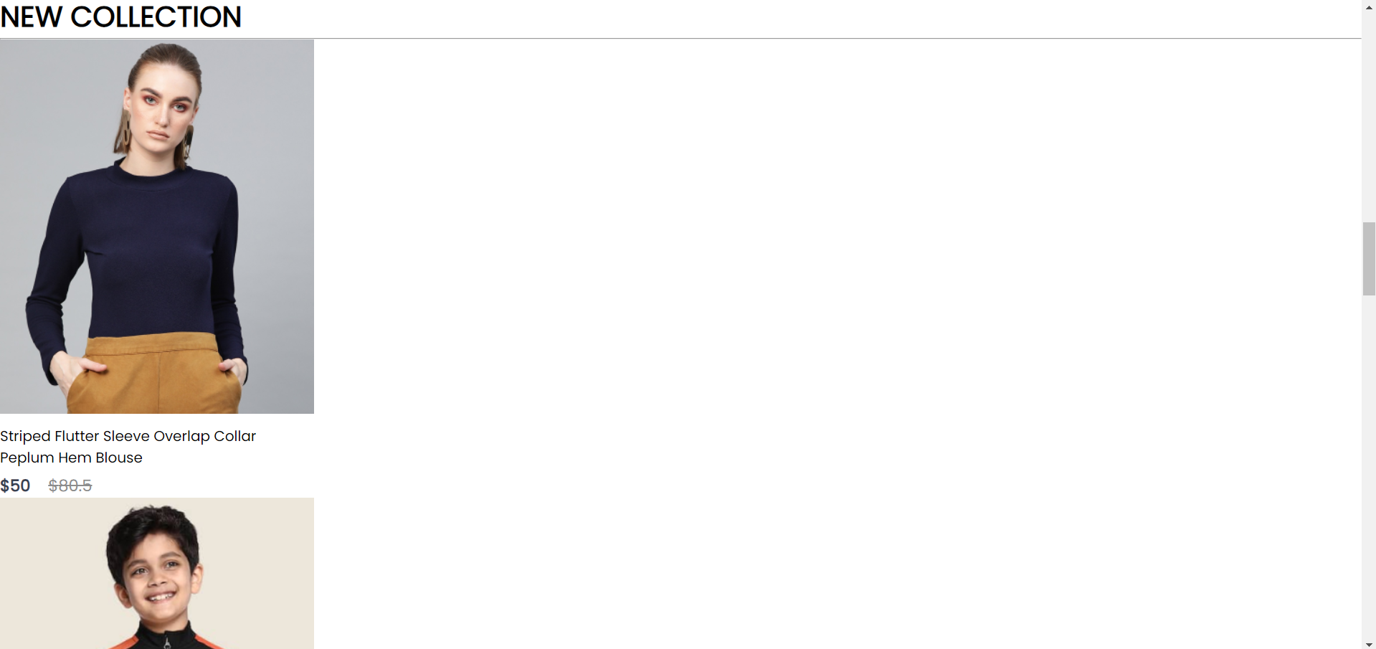

* 12.00pm to 2.30 pm: Apply CSS property to New Collection

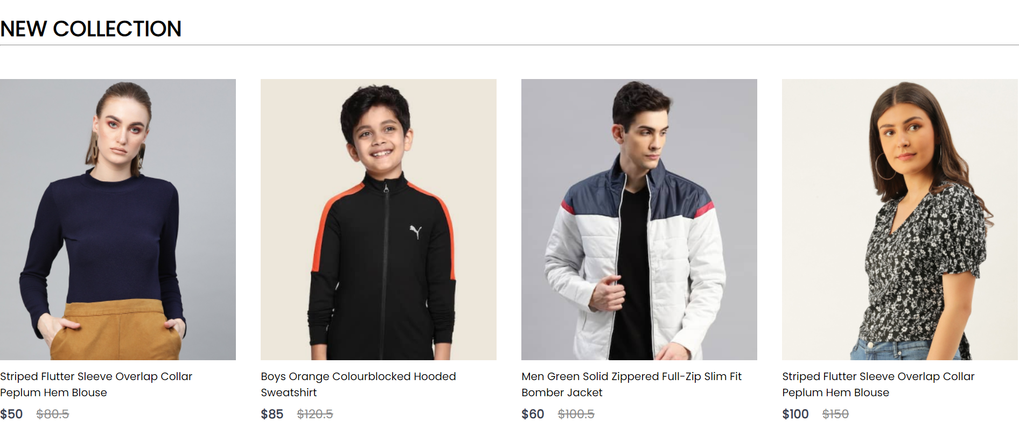

* 3.00pm to 5.00 pm: Create a newsletter component and add CSS for it.

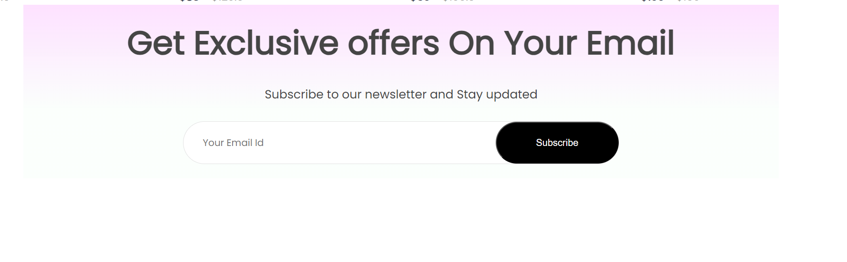

**Plans for next week:**

1. Complete Frontend Part of Project

2.Start backend of the Project.

**References:**

1. YouTube Channel: [Thapa Technical](https://www.youtube.com/@ThapaTechnical)
2. React Documentation
3. Express Documentation
4. Node Documentation
5. MongoDB Documentation

**Signature of External Guide Signature of Internal Guide**

Student Id: 22IT116

Student Name: TRUSHANGKUMAR SUMANBHAI PATEL

Reporting No:5 Week No:5 From :10/06/2024 To :14/06/2024 College ID: 22IT116

Project Title: **E-commerce website**

**WEEKLY REPORT**

**Work done in last week ( Attach supporting Documents):**

1. 10/06/2024 Monday

* 9.30am to 11.30 am: Create Breadcrum and add CSS styling in it.

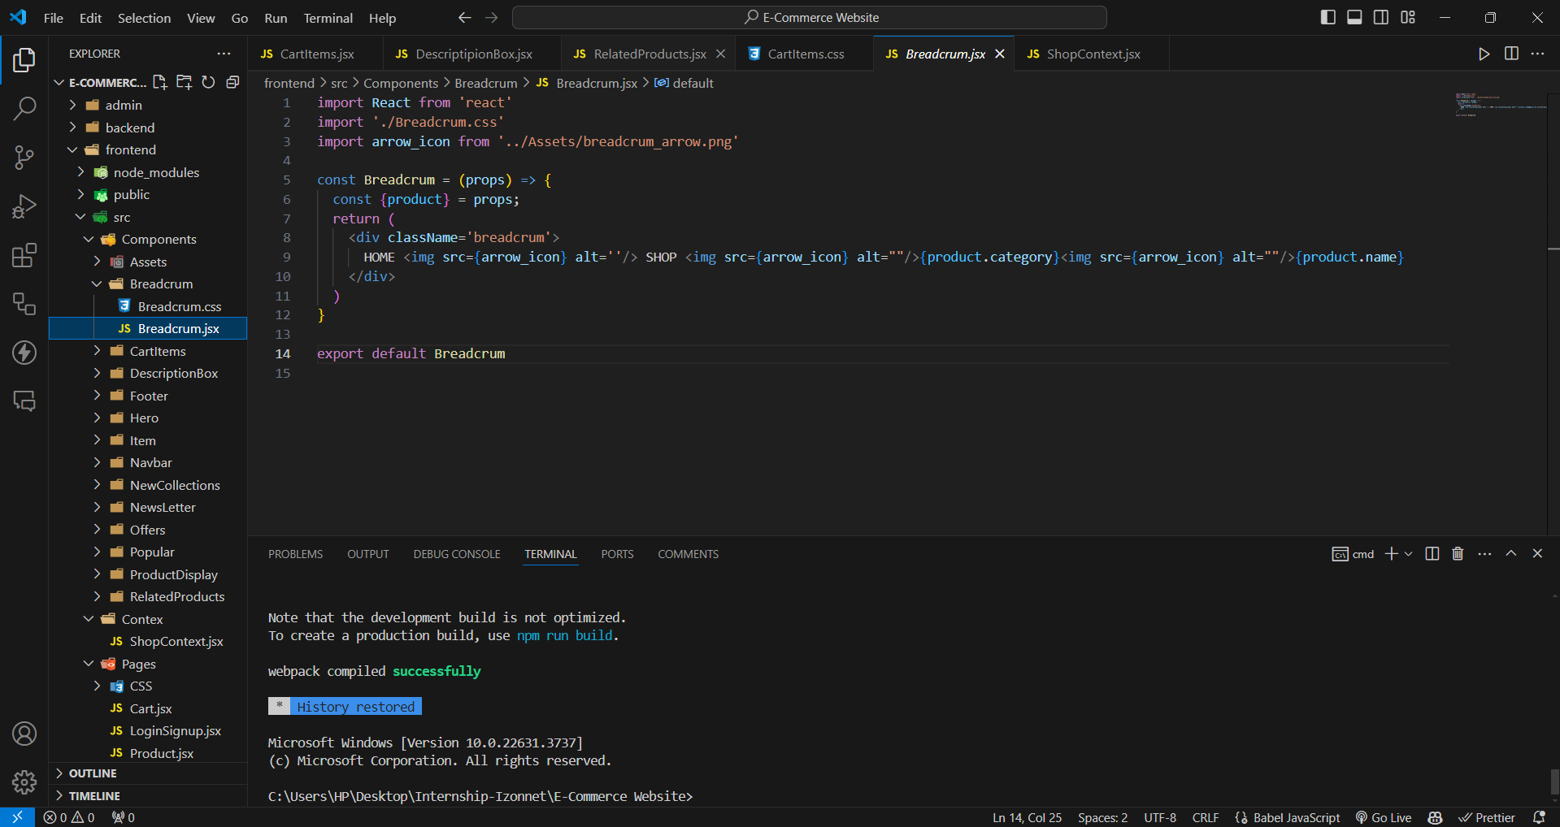

* 12.00pm to 2.30 pm: Create cart item For the Website

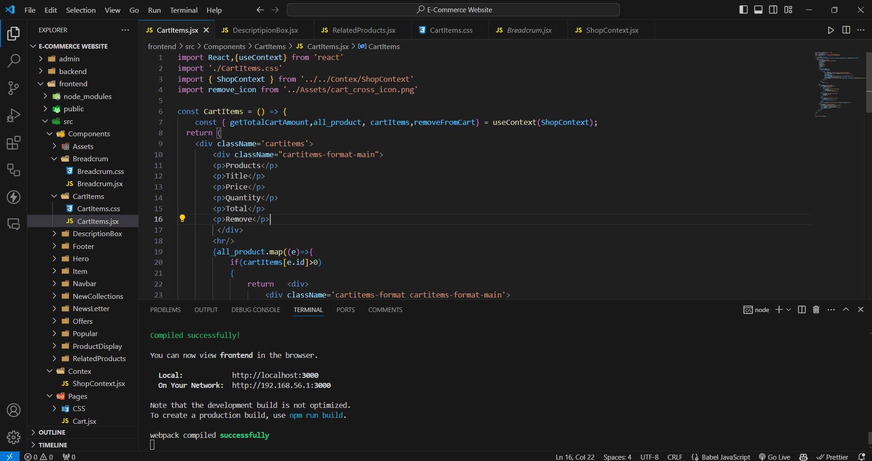

* 3.00 pm to 5.00 pm: Create Shop Context for the website

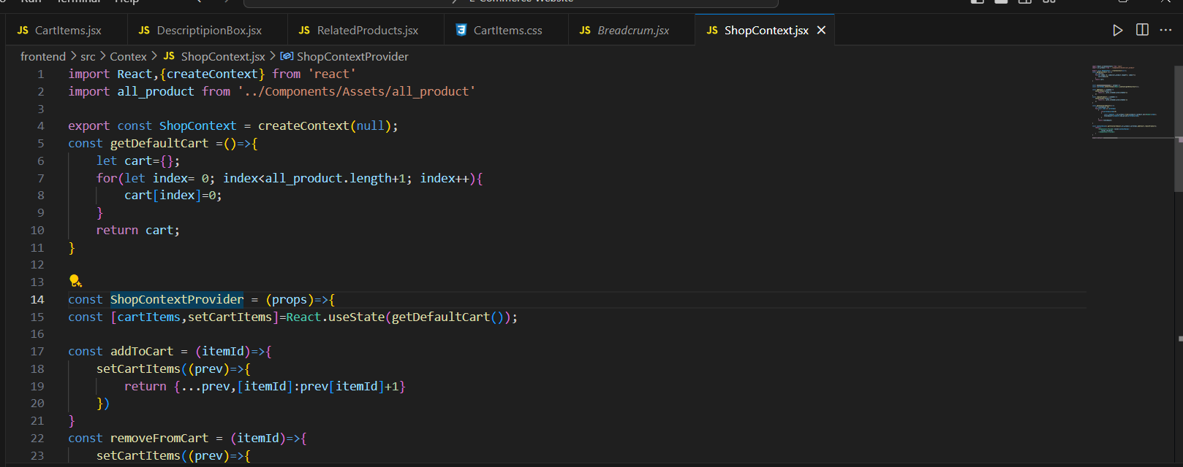

1. 11/06/2024 Tuesday

* 9.30am to 11.30 am: Create Product Display page for Website and add CSS styling.

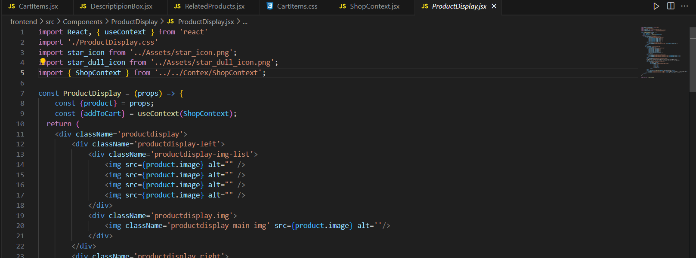

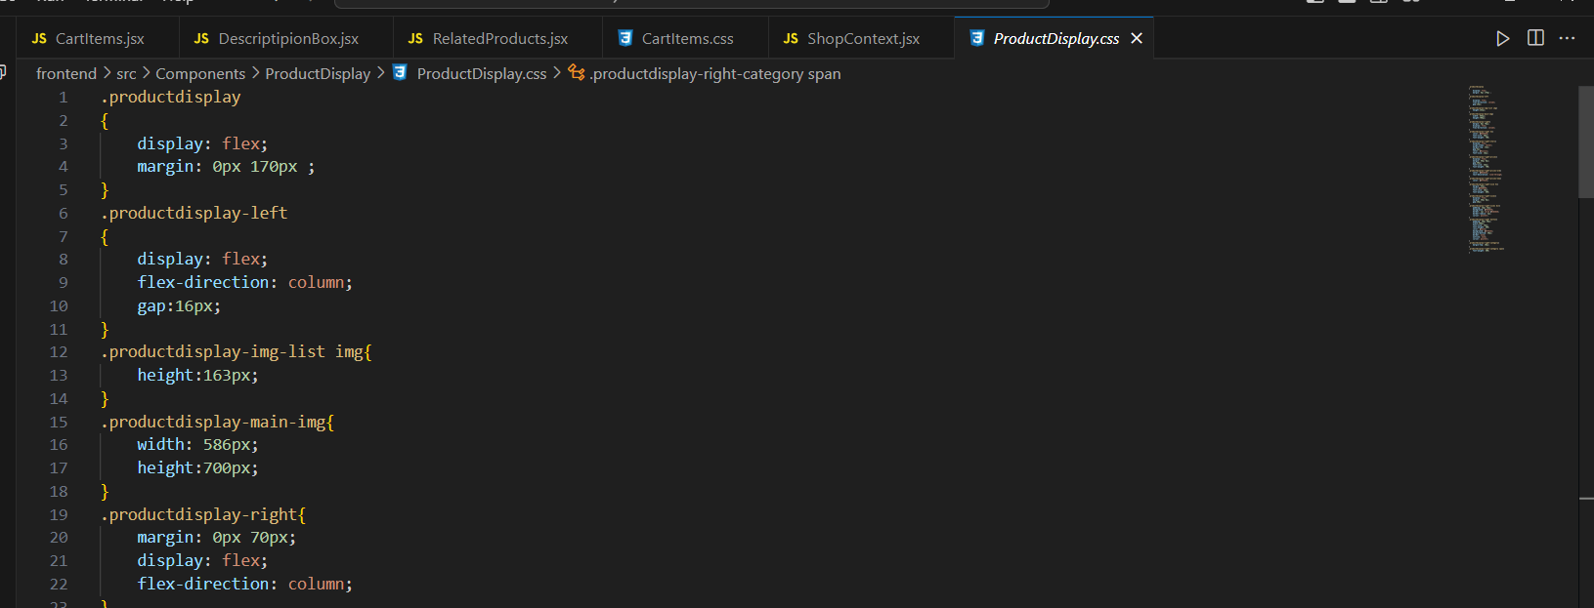

* 12.00pm to 2.30 pm: Create Related Product components and add CSS styling

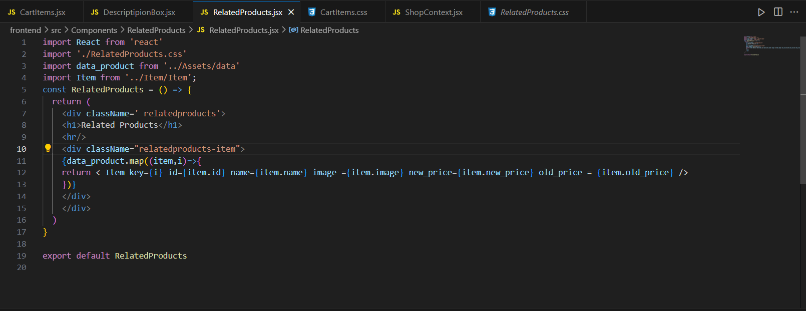

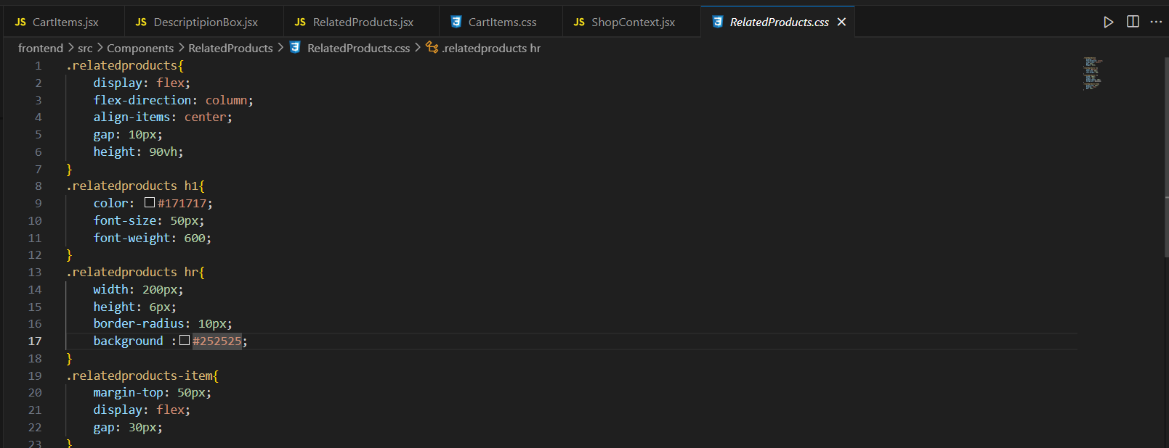

* 3.00 pm to 5.00 pm: Create a Description box for the website and add CSS styling

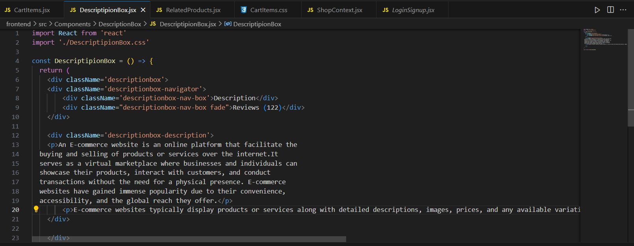

1. 12/06/2024 Wednesday

* 9.30 am to 11.30 am: Create Admin for the website and add Product component

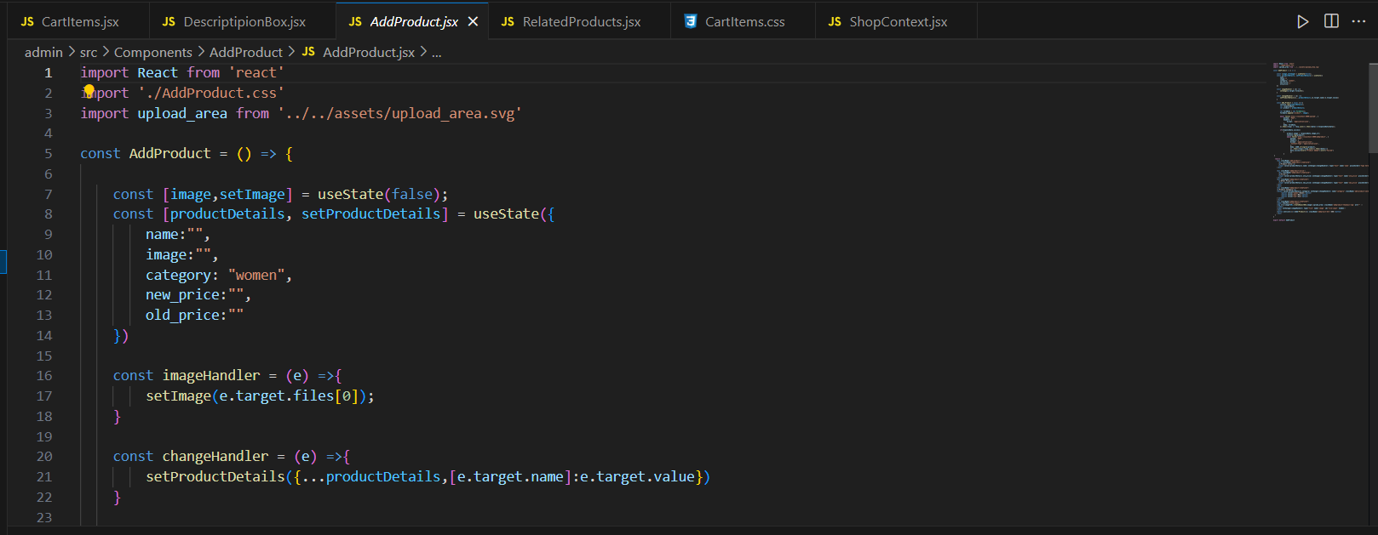

* 12.00pm to 2.30 pm: Create a Navigation bar and sidebar for the admin.

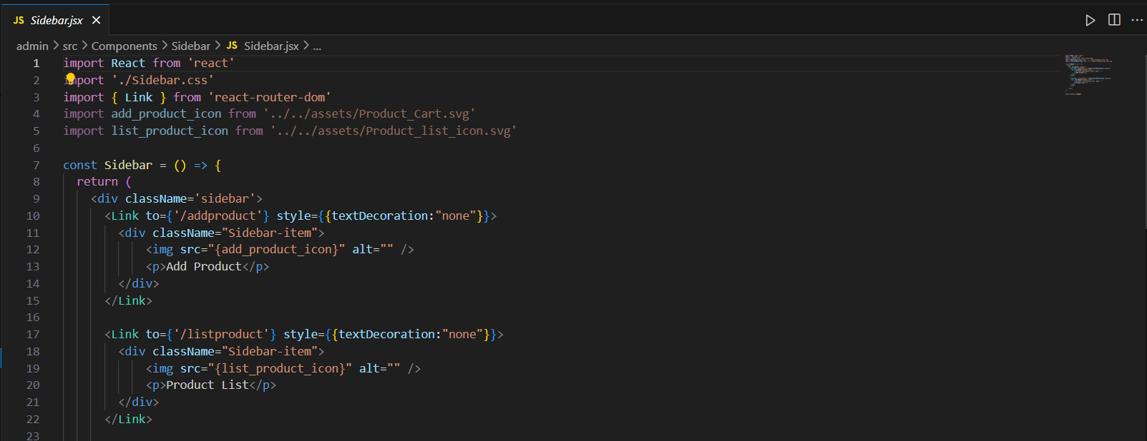

* 3.00 pm to 5.00 pm: Create Product List for the Admin

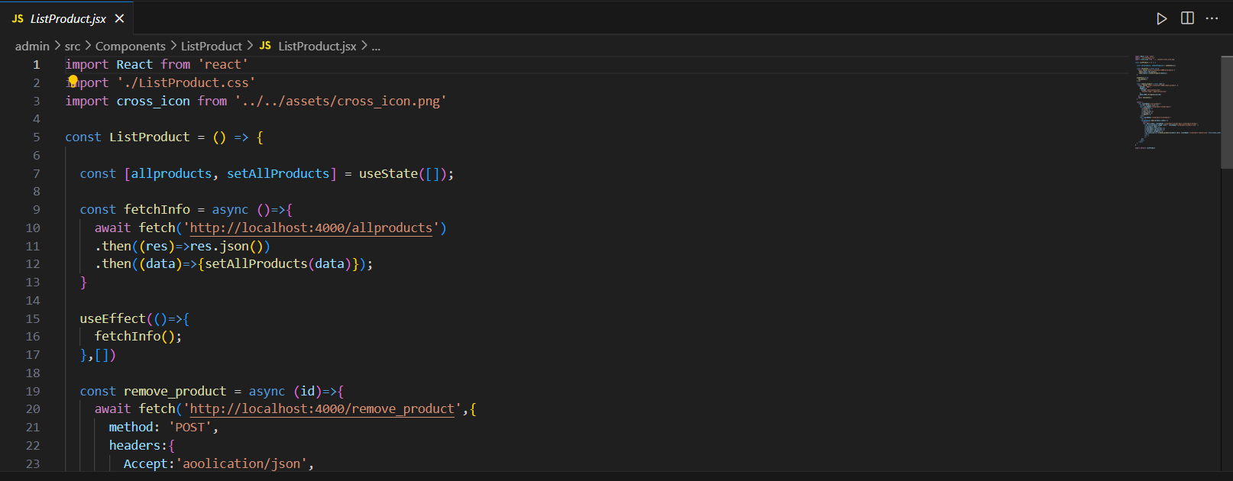

1. 13/06/2024 Thursday

* 9.30 am to 11.30 am: Connect Backend with MongoDB
* 12.00pm to 2.30 pm: Create Image store engine and uploading endpoint for images

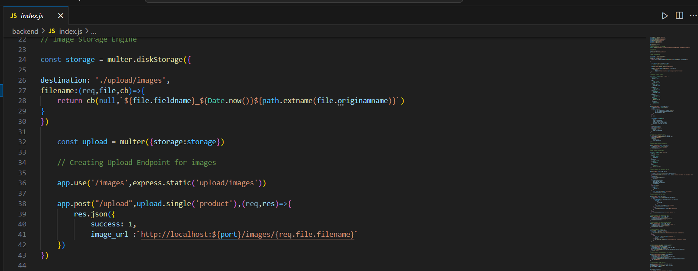

* 3.00pm to 5.00 pm: Create Schema for Product and user model.

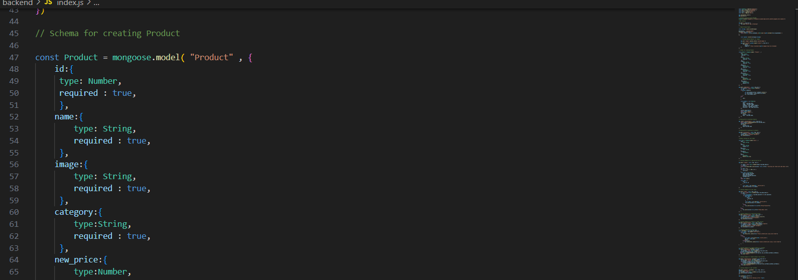

1. 14/06/2024 Friday

* 9.30 am to 11.30 am: Create a API for add product

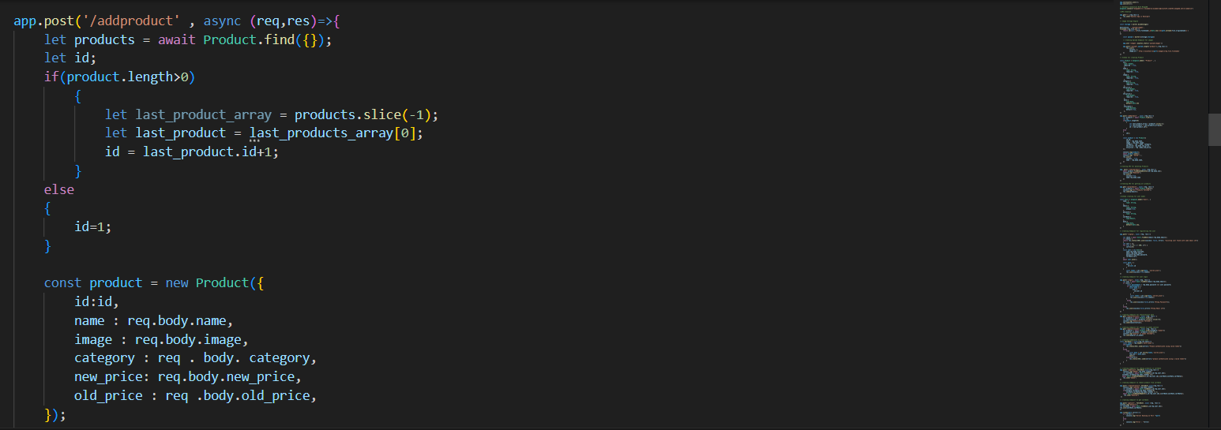

* 12.00pm to 2.30 pm: Create a backend part for login, section fetch data etc.

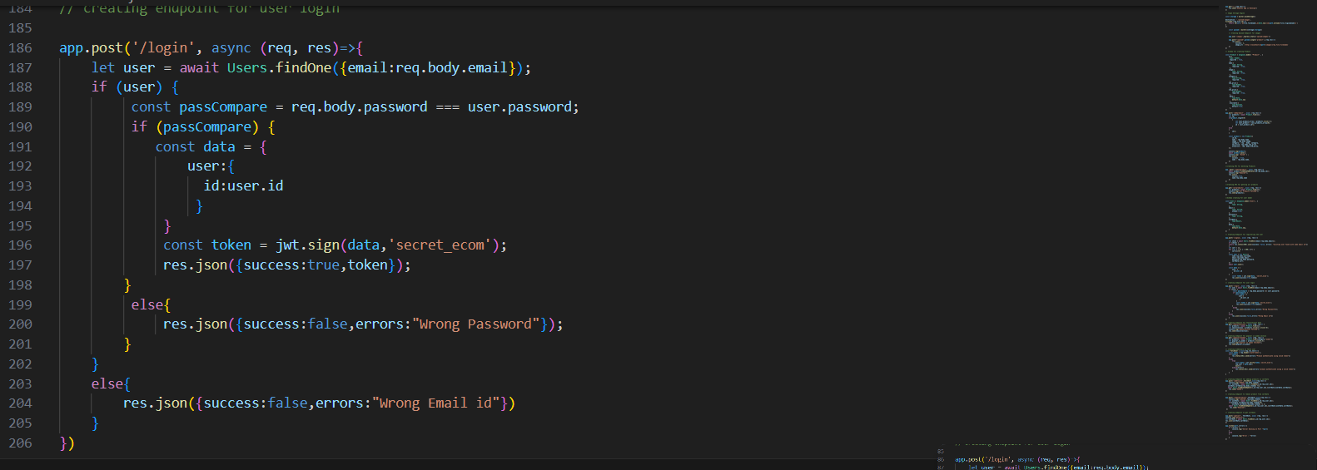

* 3.00pm to 5.00 pm: Create a backend for Cart.

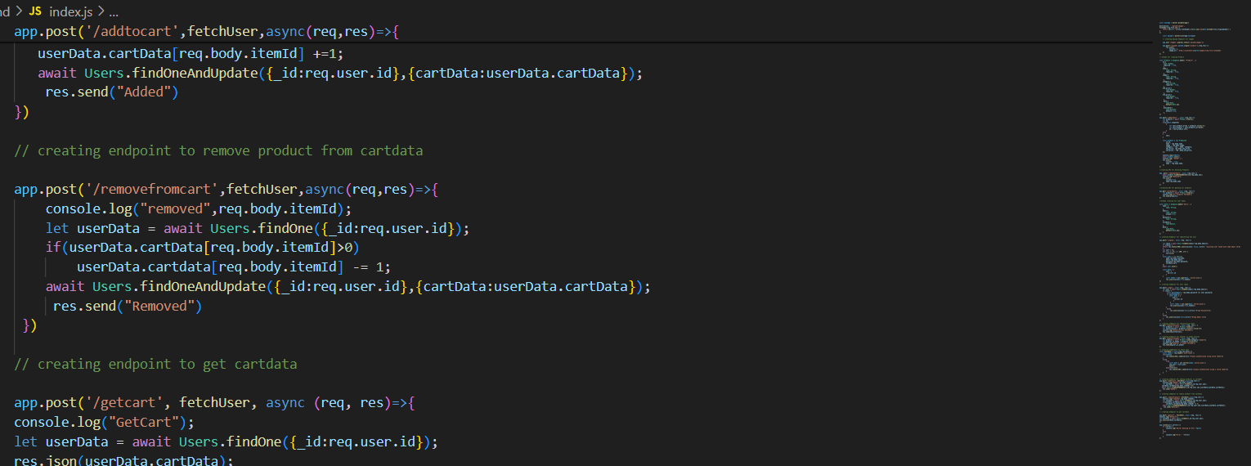

**References:**

1. YouTube Channel: [Thapa Technical](https://www.youtube.com/@ThapaTechnical)
2. React Documentation
3. Express Documentation
4. Node Documentation
5. MongoDB Documentation

**Signature of External Guide Signature of Internal Guide**

Student Id: 22IT116

Student Name: TRUSHANGKUMAR SUMANBHAI PATEL